**Classroom Activity: Write a code for update one document or multiple documents from MongoDB collection.**

**Code: Update one document using updateOne() command from the collection.**

FoodDelivery> // Update the delivery fee for "New York" in the vendor "Delicious Bites"

FoodDelivery> db.vendors.updateOne( { "vendorName": "Delicious Bites", "deliveryOptions.city": "New York" }, { $set: { "deliveryOptions.$.fee": 4 } } )

**OUTPUT:**

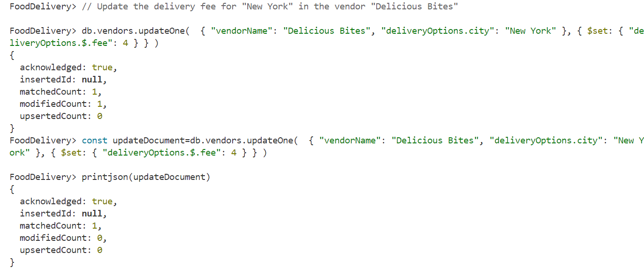

**Code: Update one document using replaceOne() command from the collection.**

FoodDelivery> // Replace the document for "Delicious Bites" with a new document

FoodDelivery> db.vendors.replaceOne( { "vendorName": "Delicious Bites" }, { "vendorName": "Delicious Bites", "cuisines": ["Italian", "Mexican"], "paymentMethods": ["Credit Card", "Cash"], "deliveryOptions": [ { "city": "New York", "fee": 4 }, { "city": "Los Angeles", "fee": 6 } ], "rating": 4.8 } )

**OUTPUT:**

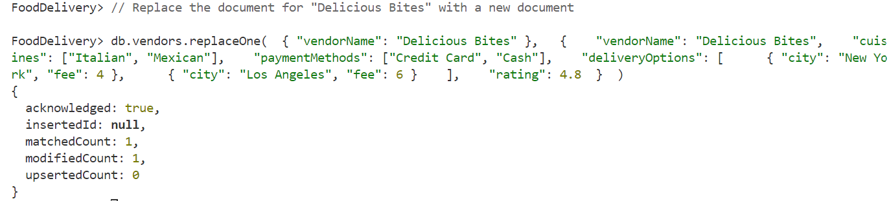

**Code: Update one document using updateMany() command.**

FoodDelivery> // Update the rating for all vendors offering "Italian" cuisine

FoodDelivery> db.vendors.updateMany({ "cuisines": "Italian" },{ $set: { "rating": 4.9 } } )

**OUTPUT:**



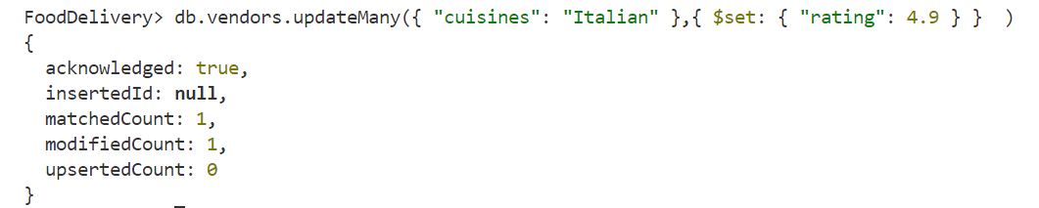

**Execution Steps:**

1. Install MongoDB compass and MongoDB shell
2. Create a new connection in MongoDB Compass
3. Create a new Database eg.)Food Delivery
4. Go to Visual Studio Code
5. Install the MongoDB for VS code extension
6. Click on the MongoDB icon on the navigation pane
7. Right click on the localhost:27017 connection
8. Select Launch MongoDB shell
9. Finally execute the above code.